

Computer practical file



VIT Bhoapl

Made by:

Aditya Gupta

**SYSTEM SPECIFICATIONS**

***HARDWARE :***

* ***Processor- Ryzen 5 *64 based processor***
* ***Motherboard- AMD chipset***
* ***RAM- 8GB***
* ***Monitor- Full HD Anti glare display***
* ***Resolution- 1920*1080***

***SOFTWARE :***

* ***Operating System- Windows 11***
* ***Programming Language- SQL and Python***
* ***Applications used- Python and Mysql***

***Index page***

|  |  |  |
| --- | --- | --- |
| ***Sno..*** | ***Questions…*** | ***Remarks*** |
| ***1*** | *WAP to implement stock data structure using list to push and poop book details. Make use of user defined functions.* |  |
| ***2*** | *Write a menu driven program using user defined functions to implement stack using list. The choices are:*  *1-Push applicant details.*  *2-List all applicants*  *3-Pop applicant and 4-quit* |  |
| ***3*** | *Write Sql statements to create table students and add the following rows in it.* |  |
| ***4*** | *Write SQL statements for following based on table students in ques 3..*  *1-Display student name, avg marks and grade in ascending order.*  *2-add a column DOB to store date of birth of students*  *3-List information of those…..* |  |
| ***5*** | *Write sql commands in a notepad file to create table with specified constraints…..* |  |
| ***6*** | *Based on table employee and empsalry. Write SQL statements for….* |  |
| ***7*** | *Write a python program to select and display all records of table Employee in database ABC ltd..* |  |
| ***8*** | *Write a python program to display all those students details from table student in database SCHOOL, whose Avg Marks are more than 75 and have non-medical stream.* |  |
| ***9*** | *Write a python to create a table applicant in database ABCLtd. And insert rows in table.* |  |
| ***10*** | *Write a menu driven program to manage student details in a student table of SCHOOL database.*  *Show Details include(sno.,Roll_no., class, Section, Firstname, Lastname,primary key,mother’s name, Address, Contact_no.)* |  |

***Output page-***

***Q1-***

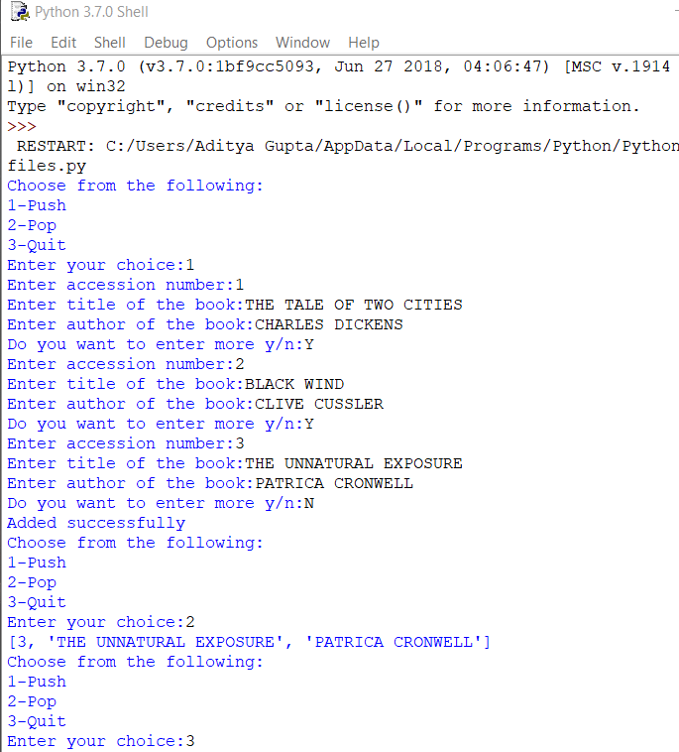

***Q2-***

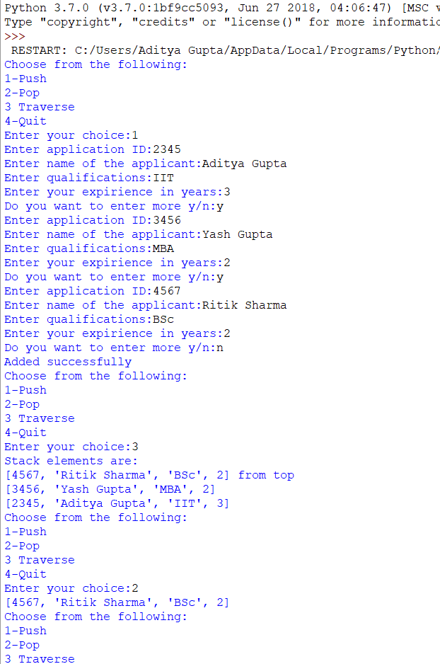

***Source code:***

***Q1-***

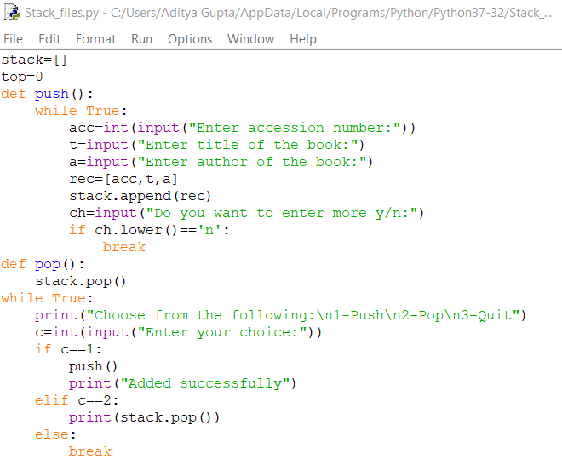

***Q2-***

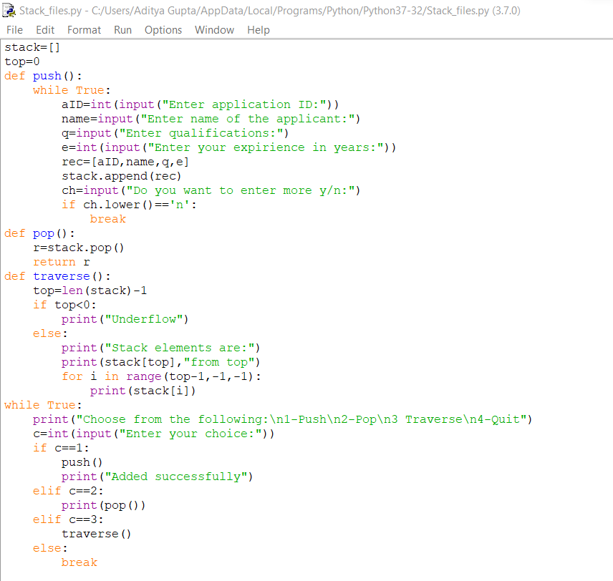

***Output page: Q3-***

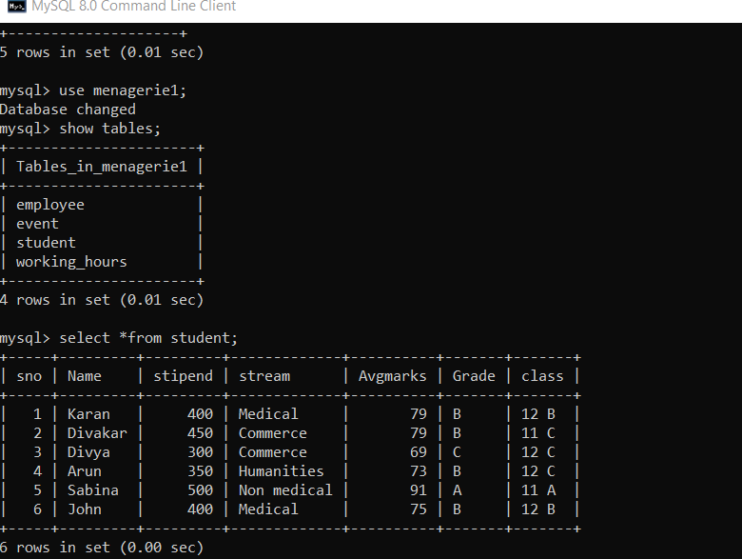

***Source code- Q3-***

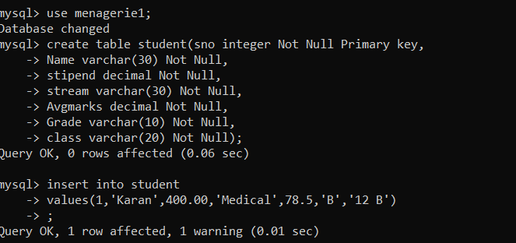

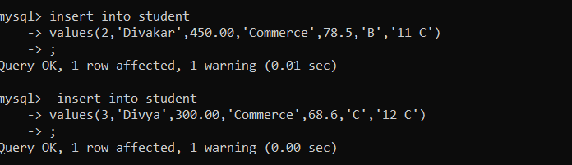

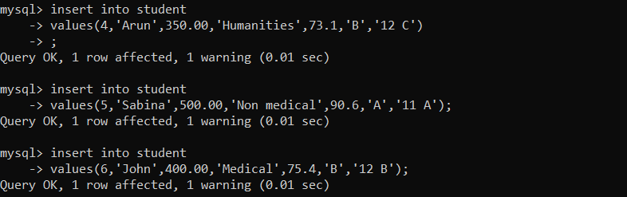

***Output page:***

***Q5-*** *Output not required…*

***Q6- i-***

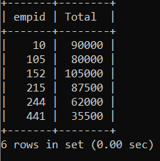

***ii-***

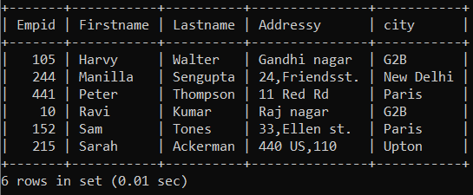

***iii-***

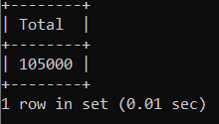

***Source code page:***

***Q5-*** 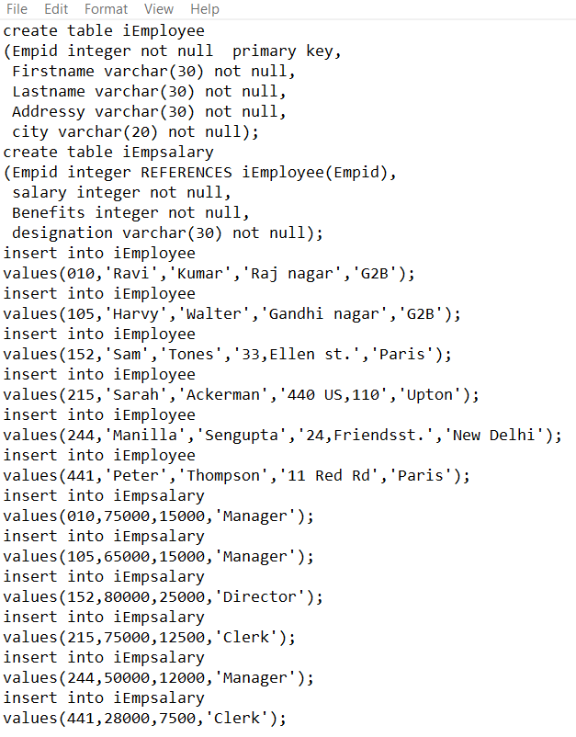

***Q6-i-***

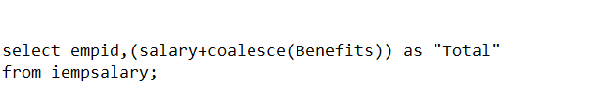

***ii-*** 

***iii-***

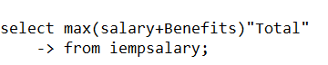

***Output page:***

***Q7-***

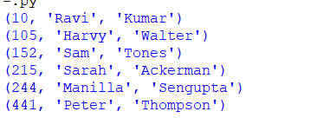

***Q8-***



***Source code page:***

***Q7-***

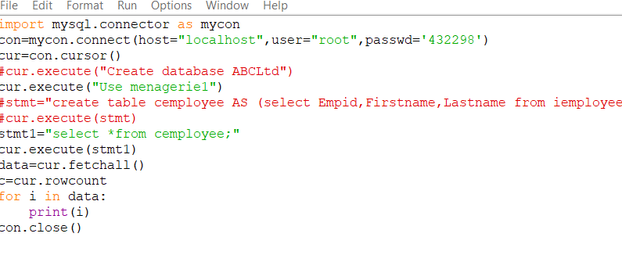

***Q8-***



***Output page:***

***Q9-***

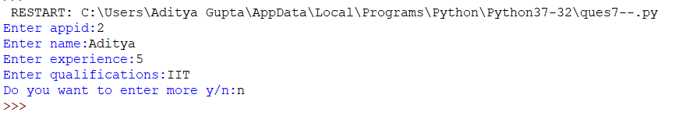

***Q4:i- output not required***

***ii-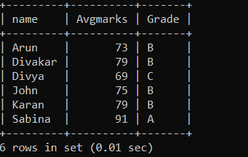 iii-***

***iv-***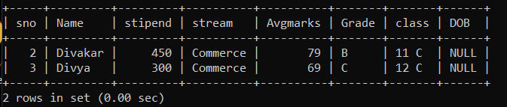

***v-***

***Source code page:***

***Q9-***

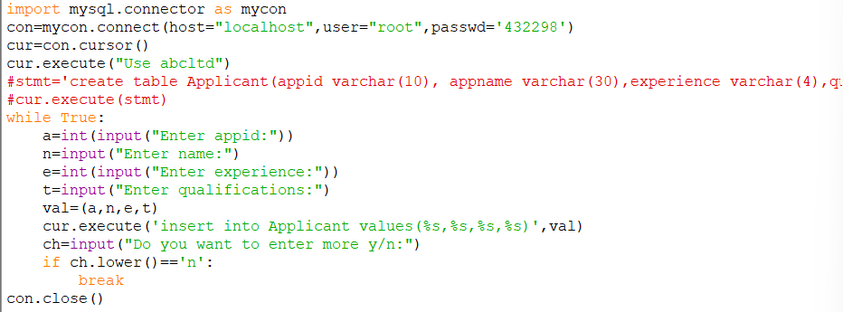

***Q4-i-***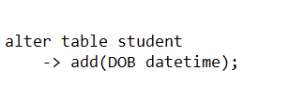

***ii-*** ***iii-***

***iv-***

***v-******vi-***